1 How to Add SMS Review in DSM

Frequency to be updated : Monthly

Click on Safety and Quality Module - > Manual & Review - > SMS Review

As per SMS process, the monthly review of the chapters is to be carried out in the DSM Platform.

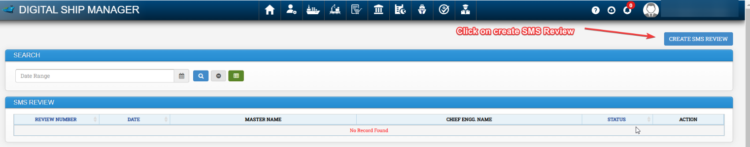

Fill all the required details and Click on submit.

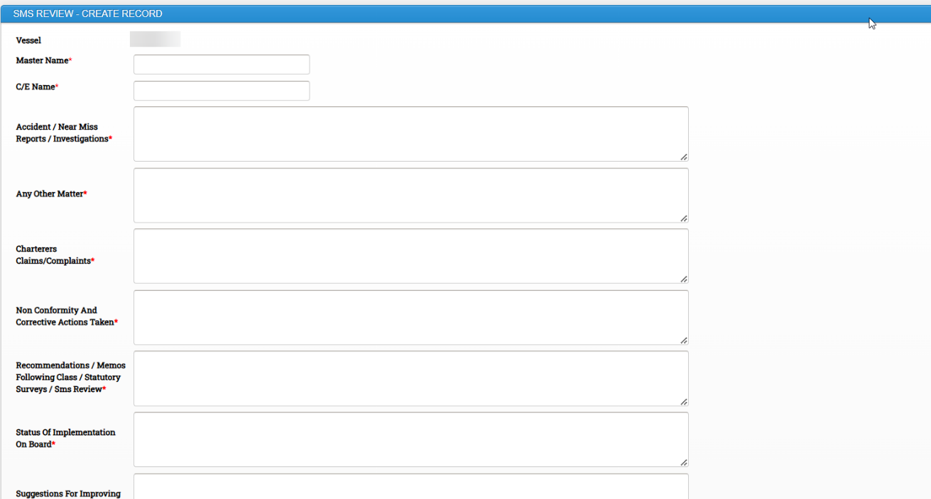

2 How to Add ISPS Review in DSM

ISPS can be reviewed by master and SSO

Frequency to be updated : Annually

Click on Safety and Quality Module - > Manual & Review - > ISPS Review

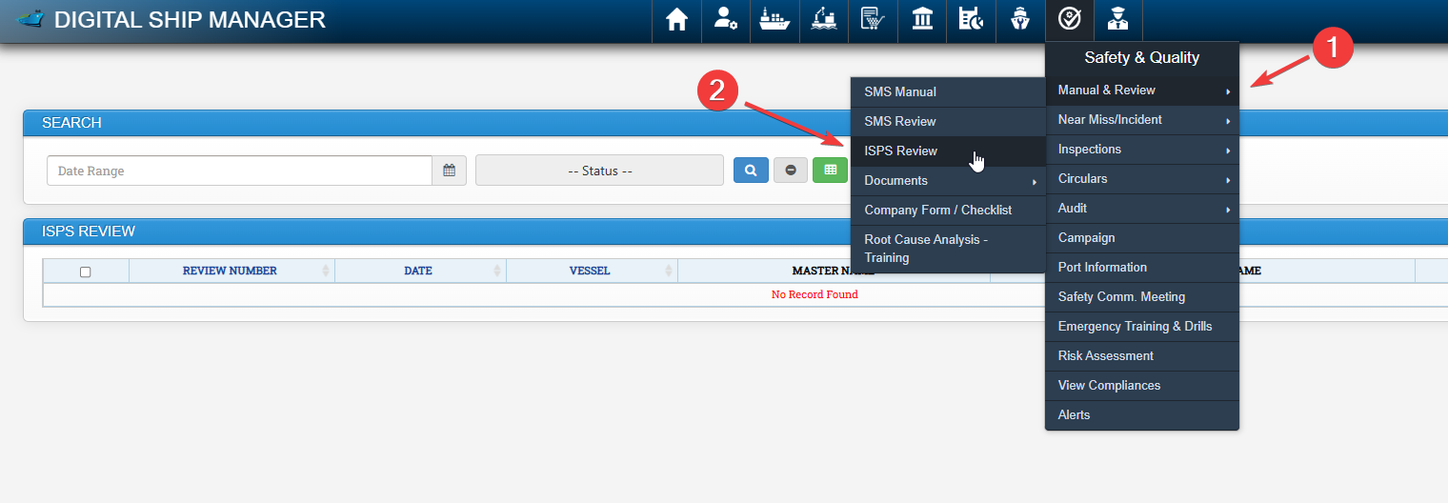

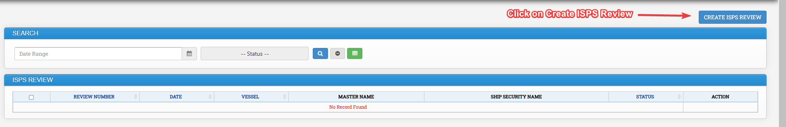

Fill all the required details and click on Submit.

3 How to Add Near miss , Accidents and Incidents in DSM

Near Miss, Accident or Incident can be updated in DSM.

Click on Safety & Quality Module -> Click on Near Miss / Incident -> Near Miss / Incident

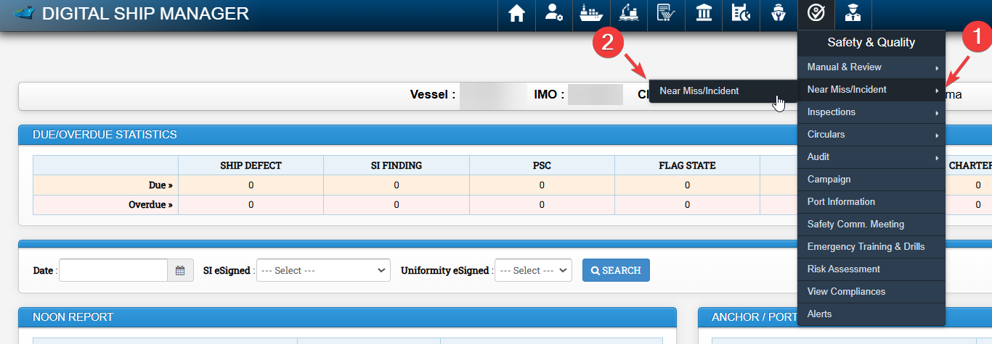

Click on Add Report

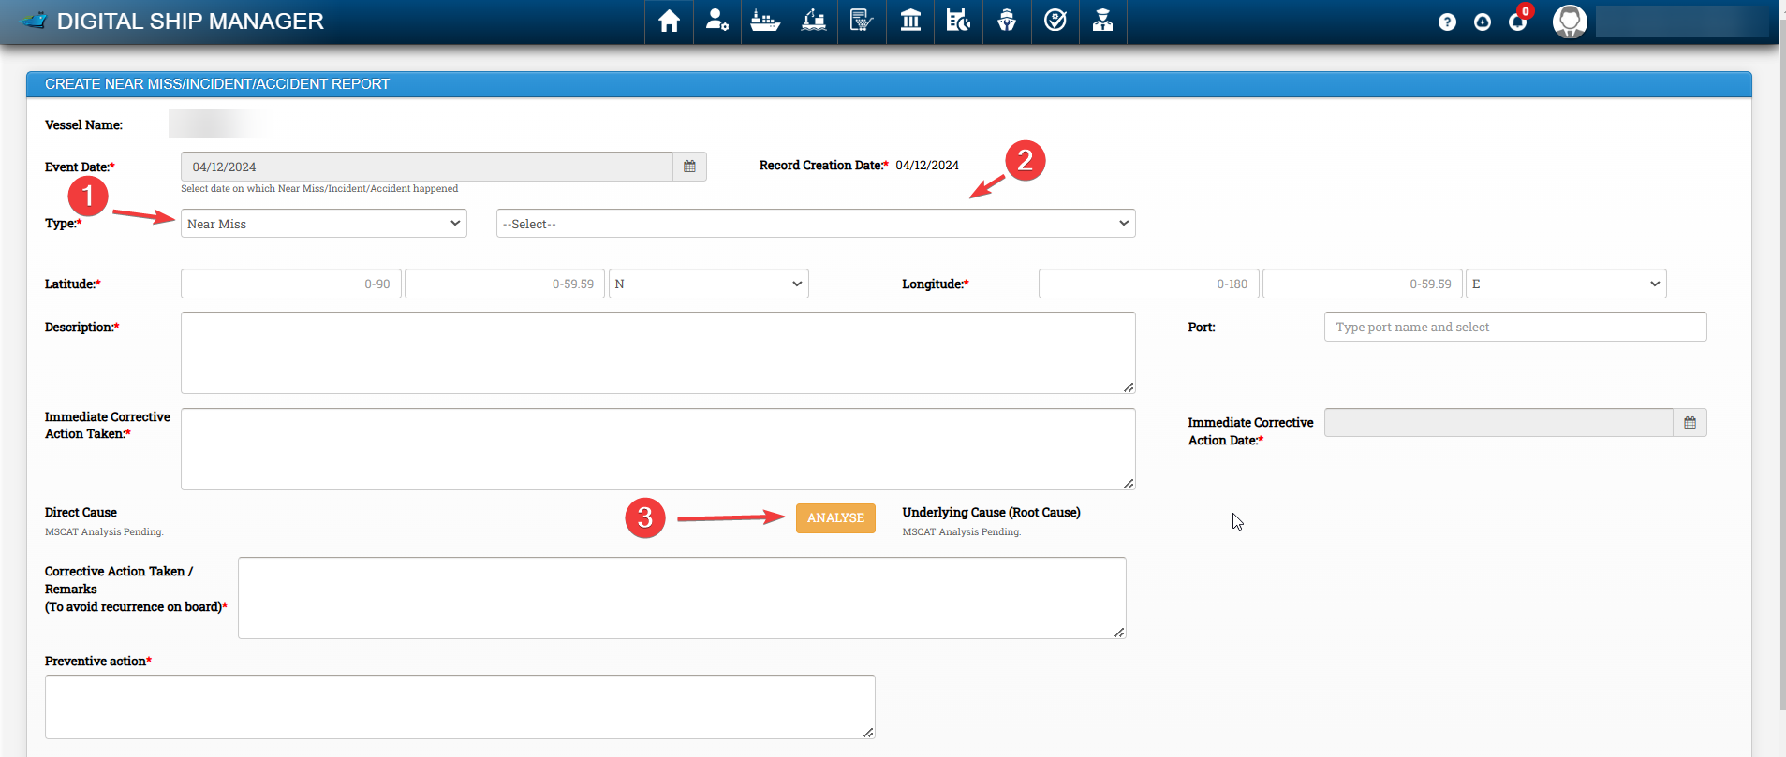

Under 1 , Please select Near Miss or Accident
Under 2 , Select Particular Category applicable

Fill all the required Data and Click on Analyse button to open Root Cause analysis Window (MSCAT)

Please select the required categories on checkbox as applicable , Fill Relevant fields if any and click on submit

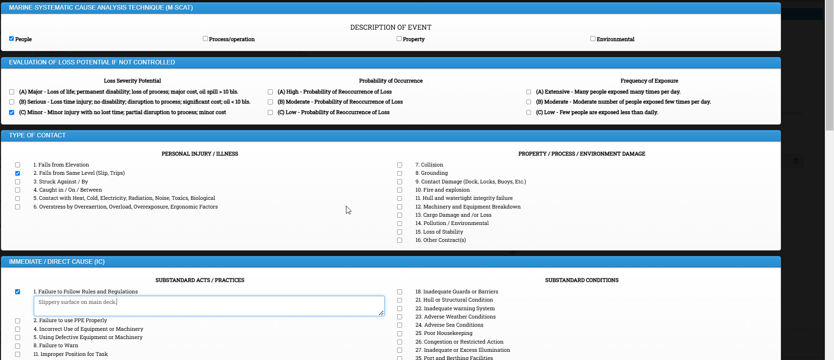

Enter Corrective action and Preventive action taken.

Upload supporting document as applicable and click on Submit button.

To review comments from office,

Click on Safety & Quality Module -> Click on Near Miss / Incident -> Near Miss / Incident

All Nearmiss / Incident Reported by the vessel will appear here.

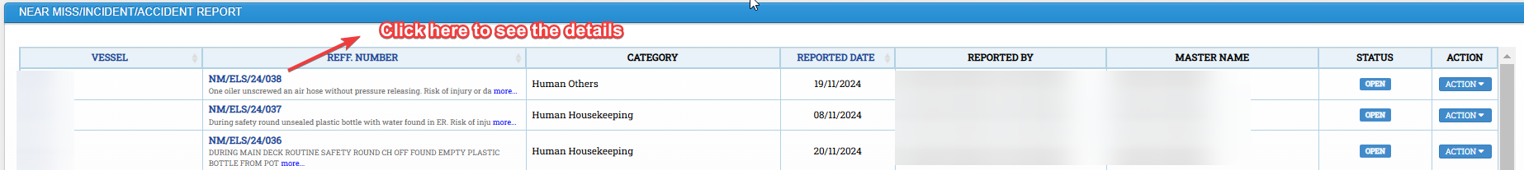

Under Verification information, Comments from office side will be visible to the vessel.

4 How to Add Flag State / PSC Inspection in DSM

Procedure to create flag state / PSC Inspection is similar in DSM.

Click on Safety & Quality Module -> Inspections -> Select Create PSC Inspection or Create Flag State Inspection

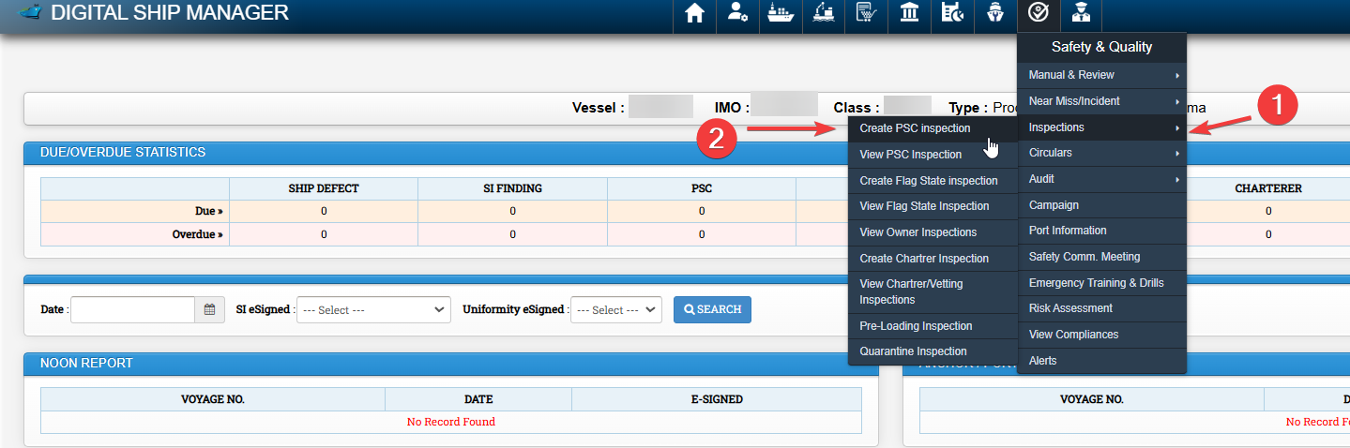

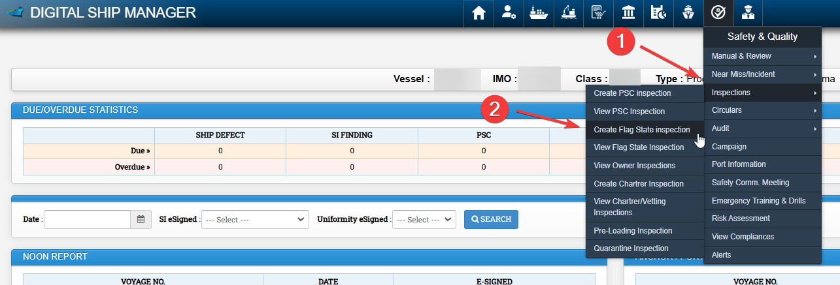

Fill the required data.

In case of deficiencies click on Deficiencies , fill the required fields and click on submit

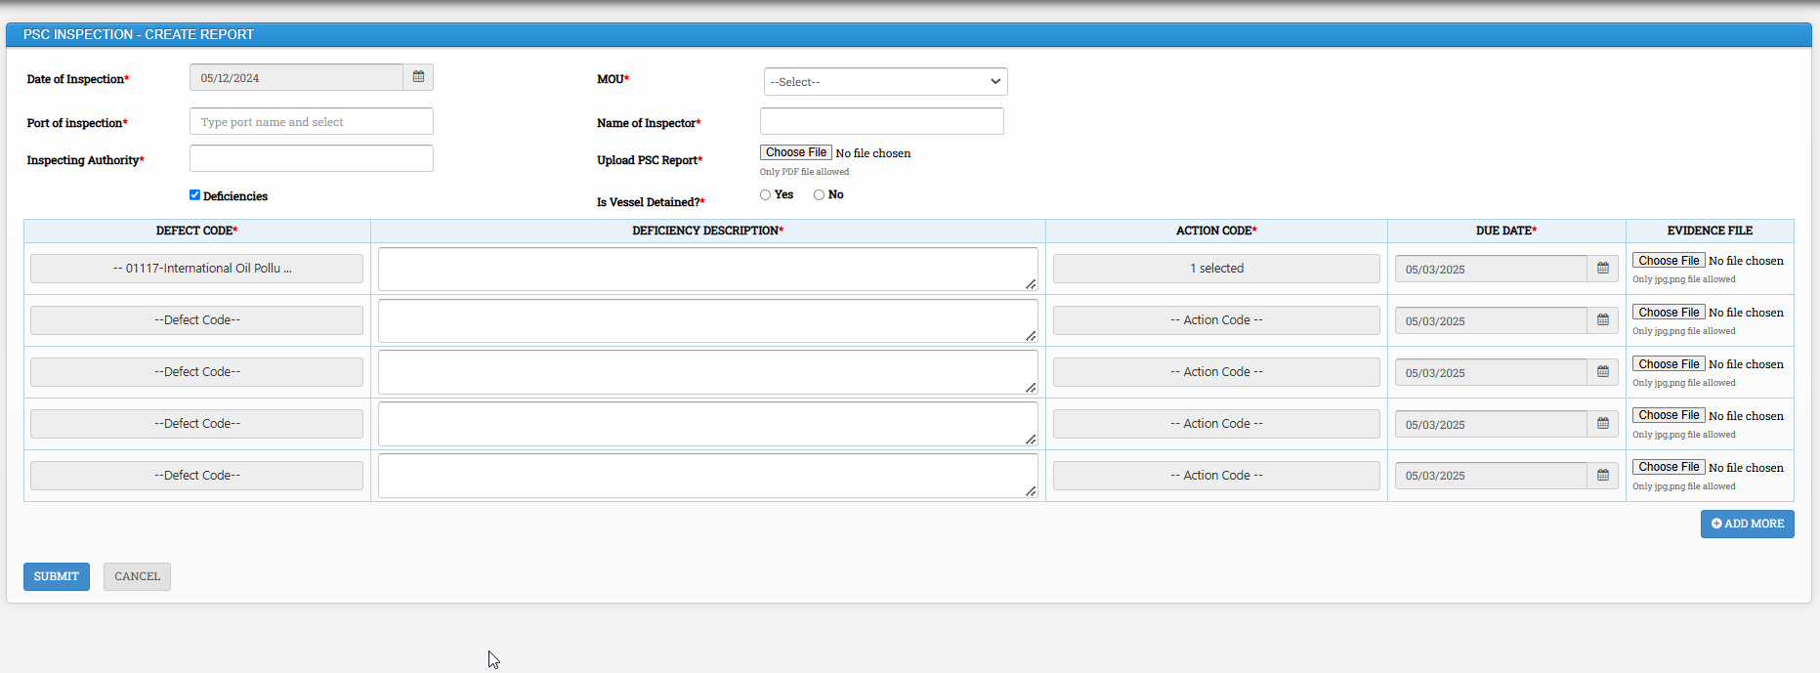

5 How to Add Safety committee meeting in DSM

Click on Safety and Quality Module - > Safety Comm. Meeting

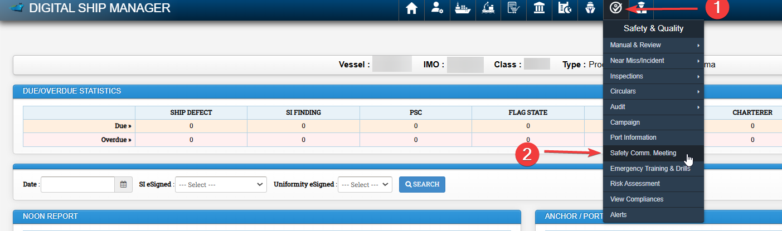

Click on Create New Report

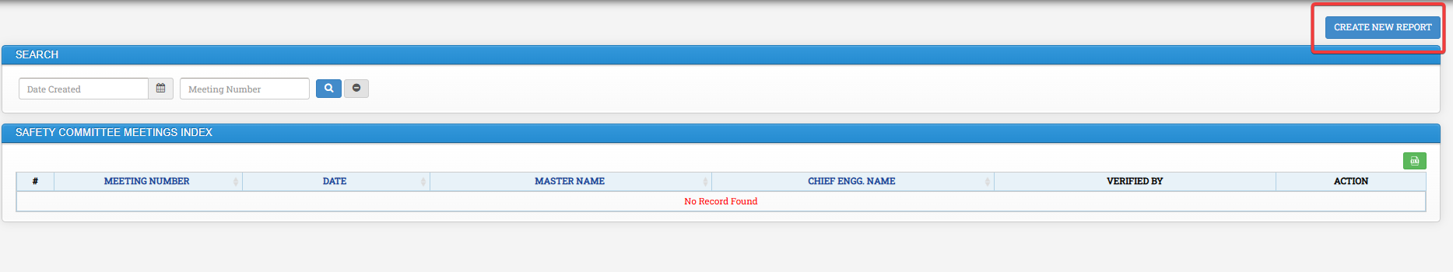

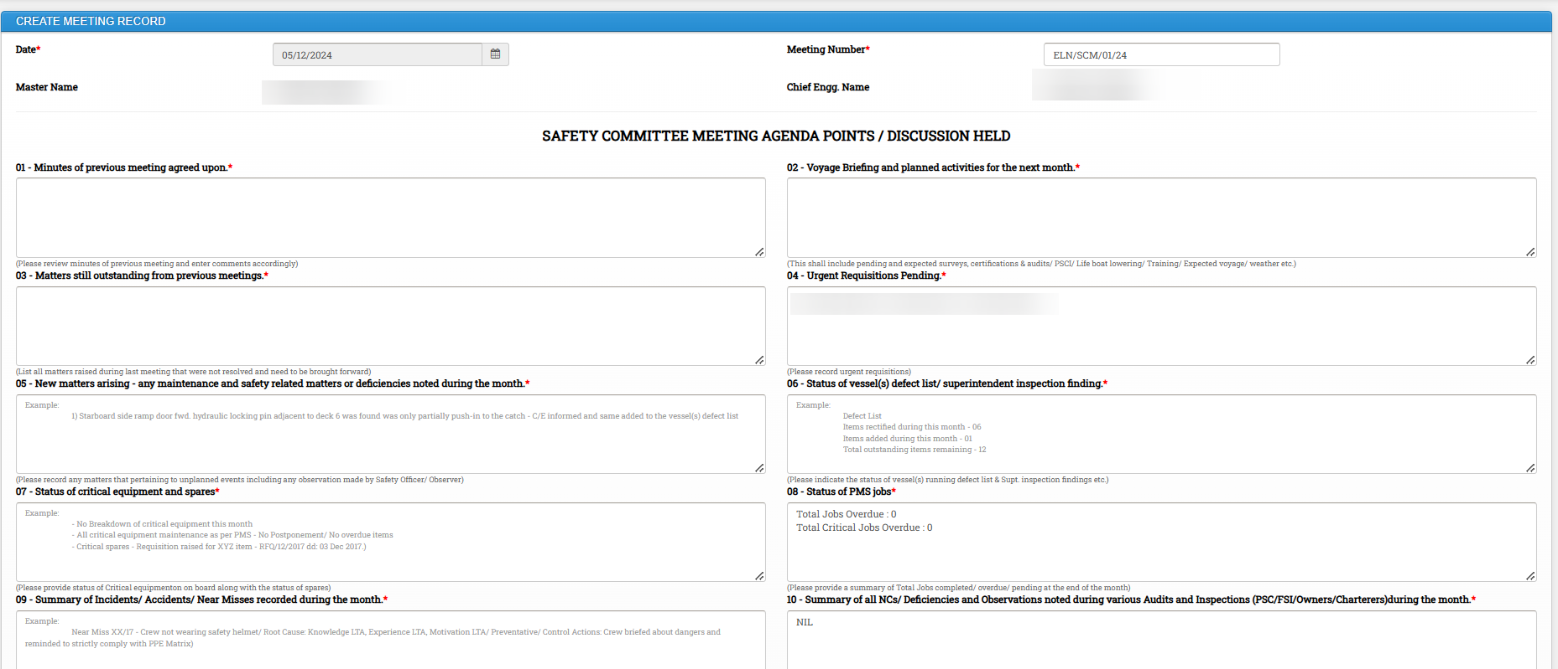

Fill all the required details , mark members who participated in the meeting and click on Submit

6 How to Update Drills in DSM

Click on Safety and Quality Module - > Click on Emergency Training & Drills

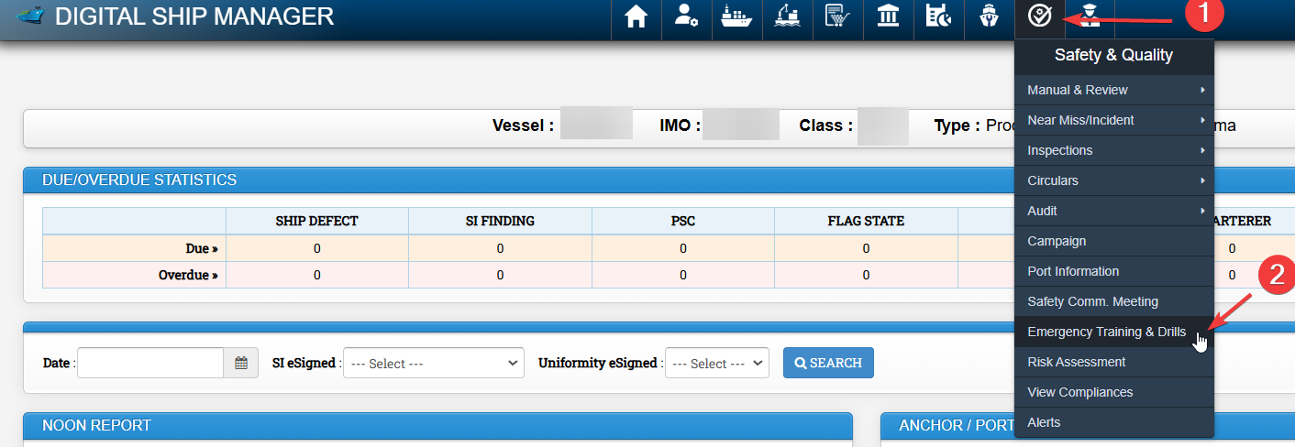

All relevant drills will appear here and status can be seen as Due , Overdue or OK under Status Column.

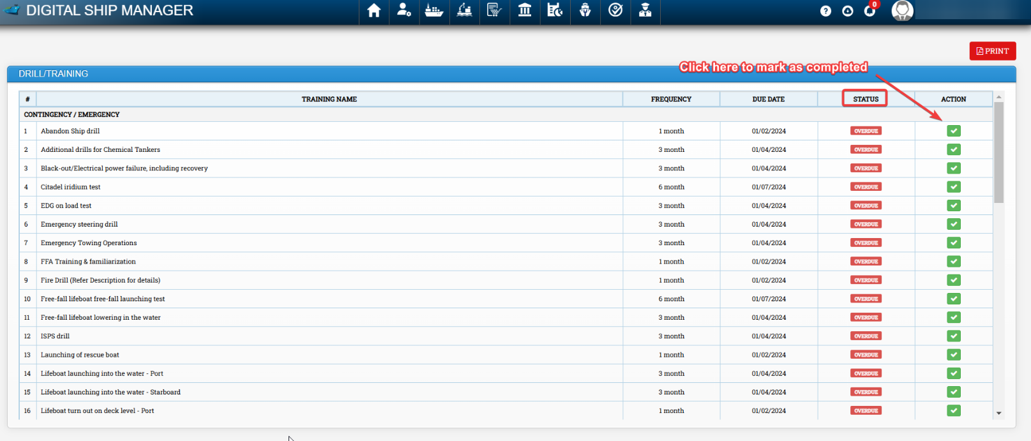

Click on Green Tick Icon (Mark as completed) to update.
Fill all the required data and click on submit.

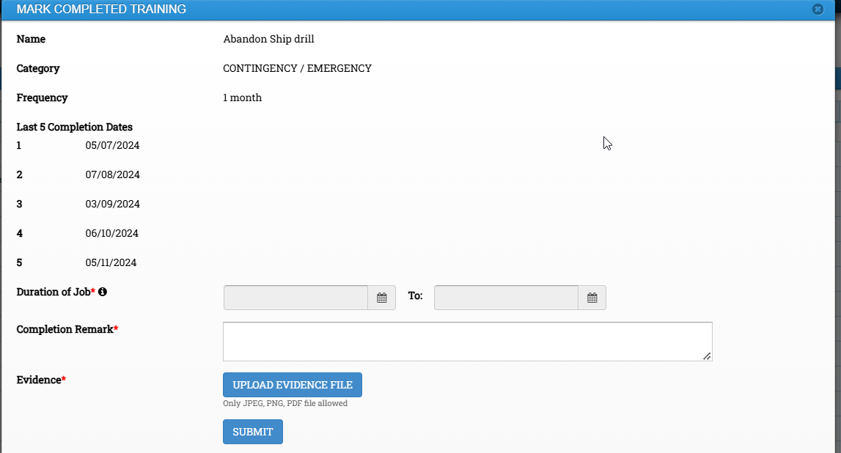

7 How to Add Masters Self Navigation Audit in DSM

Click on Safety and Quality Module - > Select Audit -> Click on View Audit

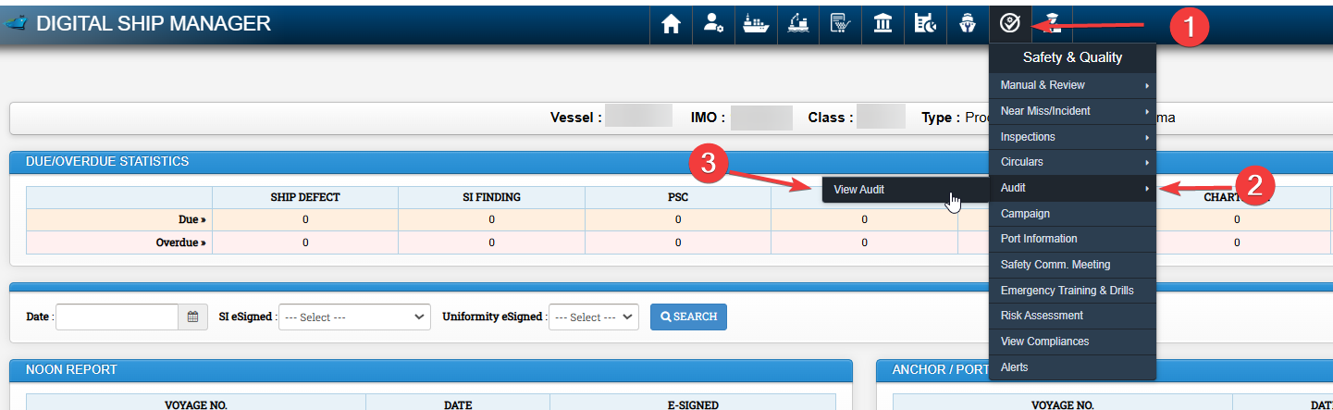

Existing audit records may be viewed here.

Click on Create audit record

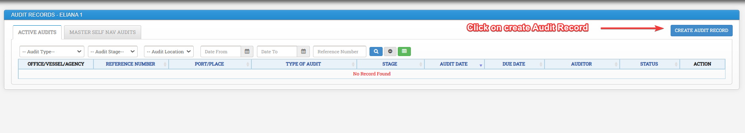

Fill the required information and click on submit.

